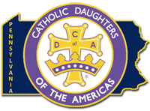

PENNSYLVANIA STATE COURT

“You are the salt of the earth…You are the light of the world…” Matthew 5:13-16

1530 Hollywood Drive
Lancaster, PA 17601

DISTRICT DEPUTY REPORTING FORM FOR COURT MEETINGS

Name of District Deputy _____________________________________
Assigned to Court _____________________________________
Date of this Report _____________________________________
Purpose _____________________________________

Meeting

- Was the court business meeting conducted according to proper procedure? ____________

- How many members were in attendance? ____________

- Were all officers in attendance? ____________ If not, who was missing? ____________

- If officer was not present, was she excused? _______________________________

- Was the Court Chaplain or Spiritual Advisor present for any part of the meeting? ____________

- Did the Court Regent use a prepared agenda? ____________

- Did any Circle of Love Chairman report on her area? ____________

- Was there a speaker at the meeting? ____________ If so, who and what was presented?
____________________________________________________________________________

- Did the members participate in any projects at this meeting? ____________
As accurate as possible, state your overall observation of the court.

